**East West University** 

**Project Report**

**Title:** Design a full-fledged network for an organization with multiple subnets.

**Course Code:** CSE405

**Course Title:** Computer Networks

**Section:** 03

**Spring: 2021**

**Submitted to:**

Dr. Anisur Rahman

Assistant Professor

Department of Computer Science & Engineering

**Submitted by:**

Md Fahimul Islam

ID: 2017-1-62-022

**Date of submission:**

21-05-2021

**Title:** Design a full-fledged network for an organization with multiple subnets.

**Project Background:** INTERNATIONAL Apollo University, is an enterprise like East West University, owns a large number of computers, with a complex network infrastructure. Apart from wired internet access to all the classrooms, labs, employee PCs, library and other administrative and academic wings, the university also provides wireless internet access for everyone. On top of that the university runs a number of complex networked systems to support several of its business process like admissions, advising, results, eTender, library management, accounts and so on.

**Components:**

1. DHCP Server (only one)
2. DNS Server
3. WEB Server
4. Laptop
5. Pc
6. PT Routers
7. Wireless Routers (access point-PT)
8. Connectors
9. Switches [2960-24]

The primary assistance is DHCP worker, since it will help the framework to allocating a uniquel IP address to a PC as indicated by the IP-class which we utilized. This naturally IP relegating will help the university ISC.

In my project, there is one server (DHCP), which is connected with a switch that is connected with numerous other campuses that alludes to primary campuses, OSAB-1, OSAB-2, OSAB-3, OSAB-4, OSAB-5. We have made a few workers like web worker, DNS worker and DHCP worker in our fundamental campuses, and by utilizing these worker we will deal with these 5 campuses.

We have likewise wireless router which help the university student and resources to browsing web through their pc or laptonand mobile. For security reason we utilized private secret key to those router. DHCP permits moving a PC, like a PC, among different areas without reconfiguring the TCP/IP setting.

**Physical Diagram:**

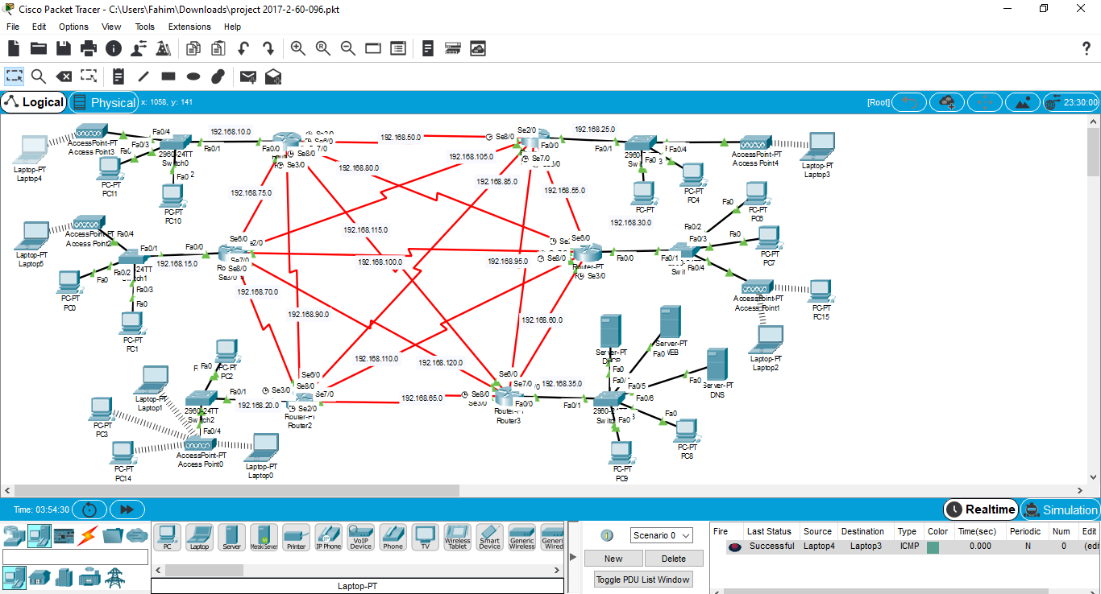

Fig1: Network Model created in Cisco Packet Tracer

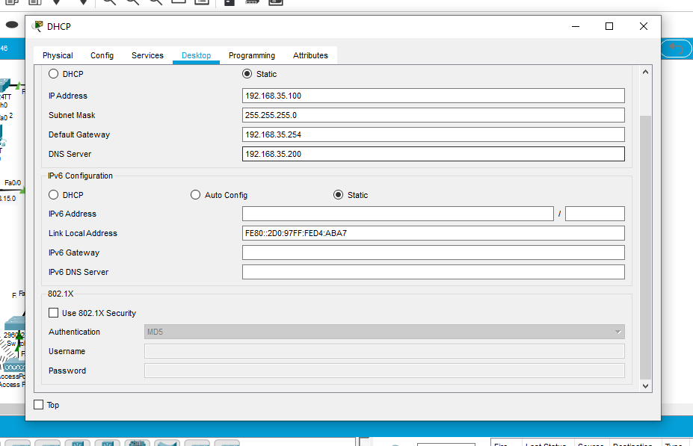Fig2: IP configuration of DHCP server

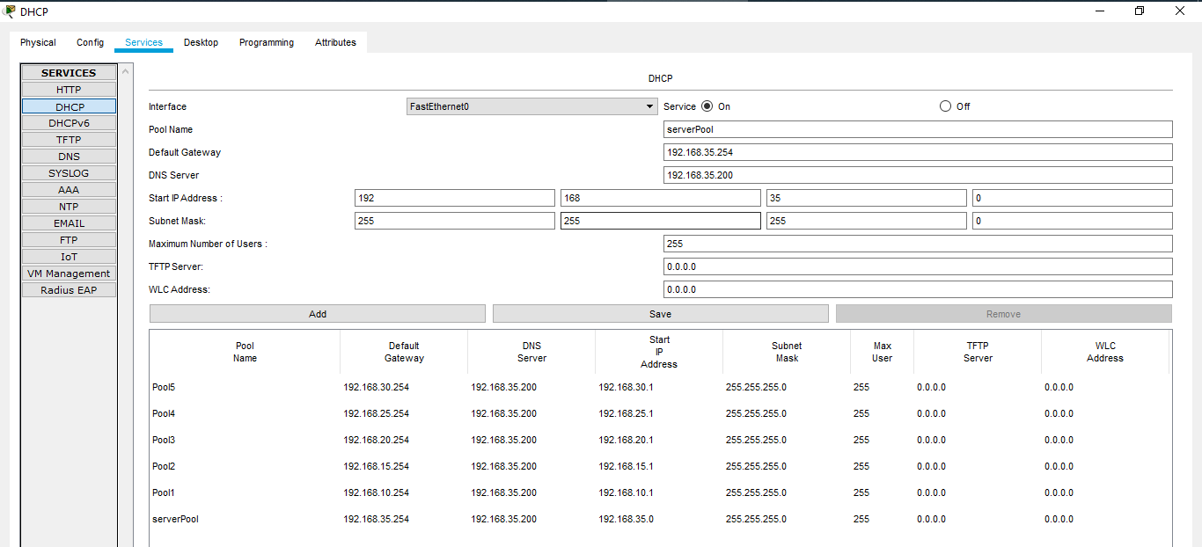

Fig 3: Creating ServerPool

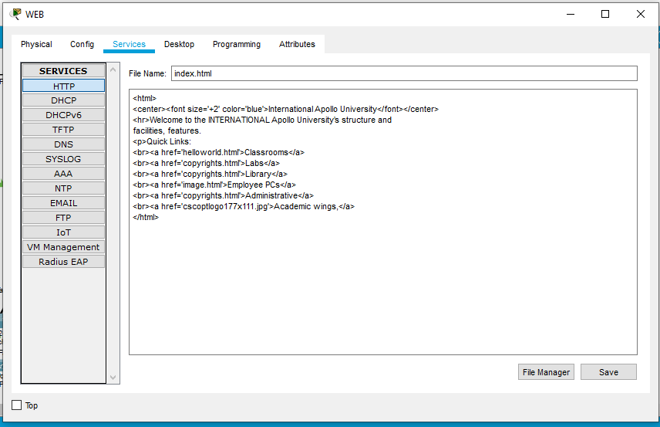

Fig 4: Web page Design

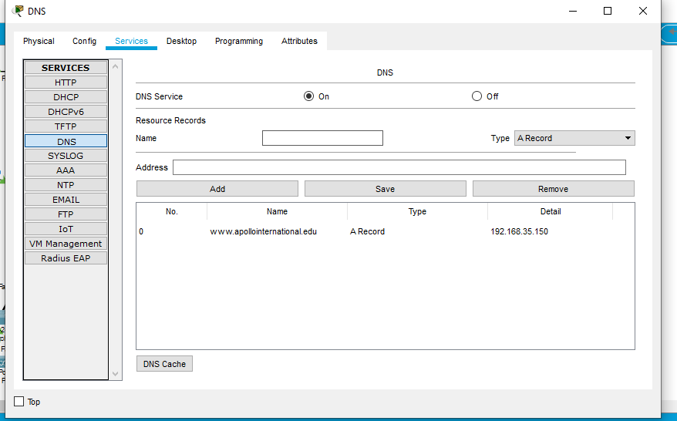

Fig 5: Address set up

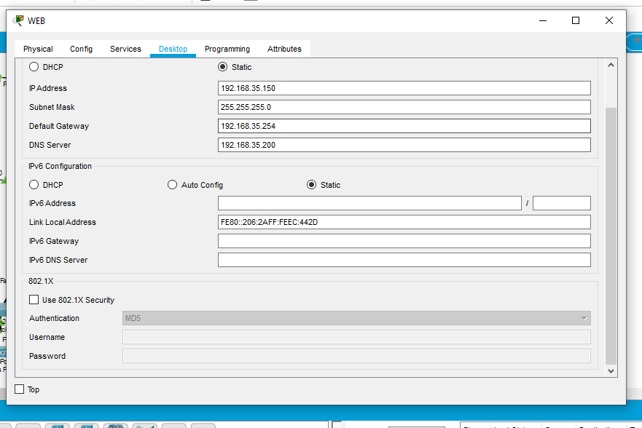

Fig 6: IP configuration of WEB server

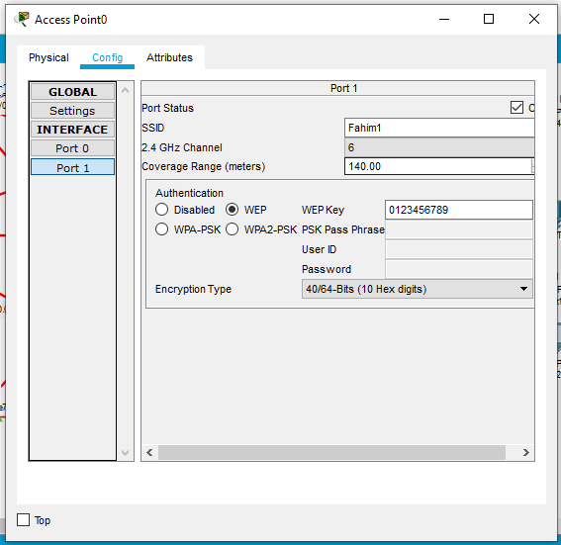

Fig 7: Wireless Router Configuration

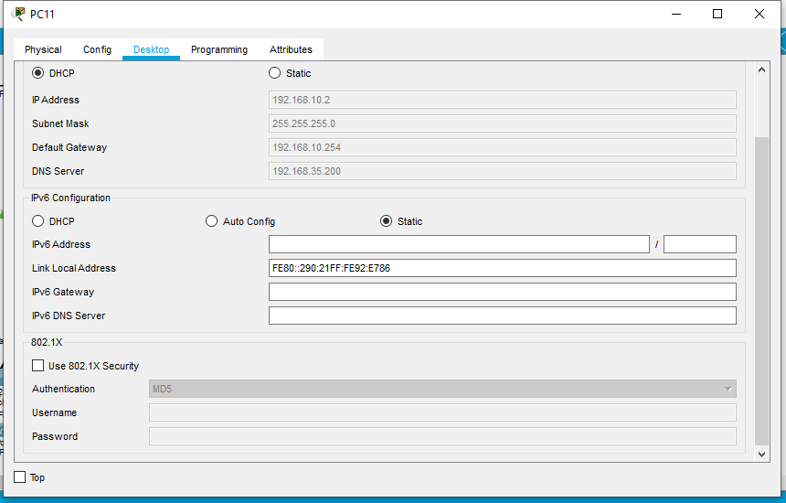

Fig 8: DHCP auto IP configuration of PC

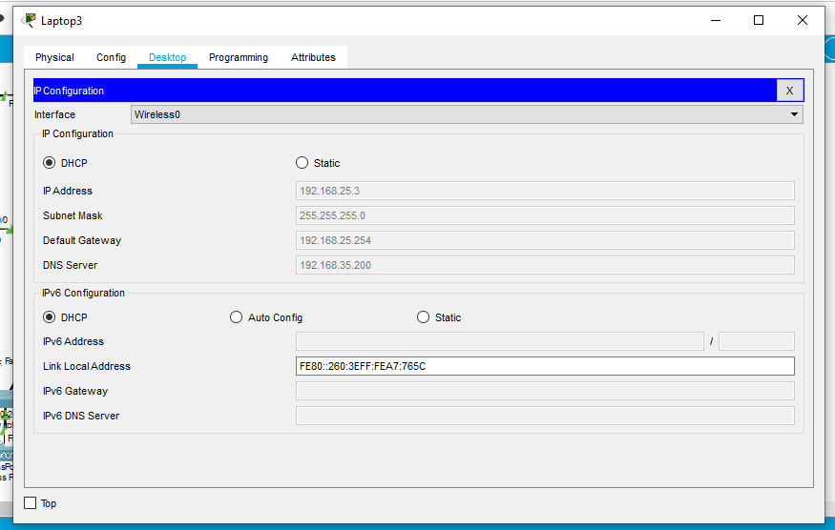

Fig 9: Wireless device

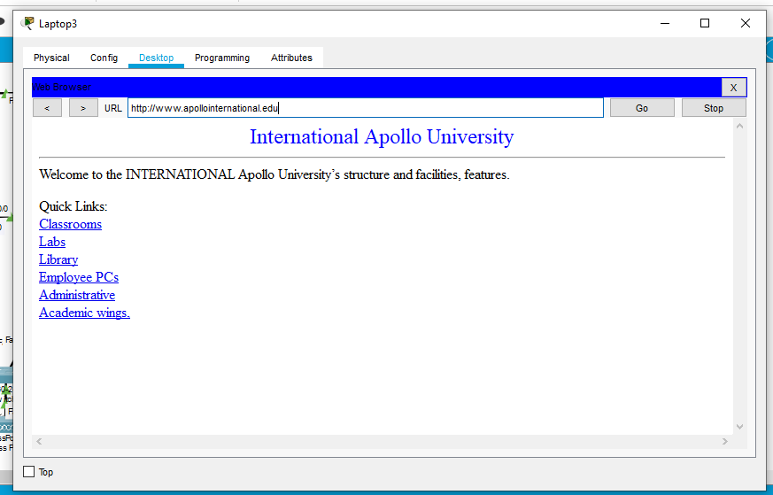

Fig 10: WEB browser page of International Apollo University

**Number of hosts:**

20 Host.

**Number of Networks:**

21 networks.

**Limitations:**

* In this design, the network IP are not from all 3 classes.
* Incorporation of subnets.

**Conclusion:**

I have faced with some issue yet the end I had the option to carry out my arrangement as per project description. I have executed DNS, DHCP, WEB worker in Cisco Parcel Tracer.